%%%%%%%%%%%%%%%%%%%%%%%%%%%%%%%%%%%%%%%%%%%%%%%
%%%%%%%%%%% PCA_SVM and its application to finger motion %%%%%%%%%%%%%
%%%%%%%%%%%%%%%%%%%%%%%%%%%%%%%%%%%%%%%%%%%%%
%%%%%%%%%%%%%% written by Huang%%%%%%%%%%%%%%%%%%%%%%%
%%%%%%%%%%%%%%%%%%%%%%%%%%%%%%%%%%%%%%%%%%%%%%%
%%%%%总体思路：
%%%%%pre-process (omitted)%fMRI预处理
%%%%%translate *.img to *.mat%将预处理后的.img 文件转化成.mat 文件；
%%%%%%去基线和漂移；
%%%%%%获取左右手动数据，%做mask；
%%%%%用PCA将数据D投影到特征空间，在特征空间中用投影数据Dp训练SVM得到%%%超平面；
%%%%%%svm性能测试；
%%%%%将特征空间中用svm训练的超平面wp投影回原始数据空间，得w用于成像；
%%%%%
%%%%%

%%%%%

% clear all
% clc
% number=input('Please input data number: ')
% %number=160;
% a = spm_get(number,'*.img','Please choice data');
% [number,k]=size(a);
% %spm2 vesion
% aaa(1,:)= strrep(a(1,:), 'img','hdr');
% [hdr,otherendian] = spm_read_hdr(aaa(1,:));
% dim(1:3)=hdr.dime.dim(2:4);
% % ********fix base*************
% %temp=0;
% %i=2;
% tt=dim(1)*dim(2)*dim(3);% 53*63*46
% aa=zeros(dim(1),dim(2));
% for i=1:number
% aa=read_data(a(i,:),dim);
% %temp=temp+y;
% ss(:,i)=reshape(aa,tt,1);
% i
% end
% clear tt aa a aaa hdr otherendian dim
load fmridata1.mat
clear s
%%%%% remove the baseline and the detrench%去基线和漂移
[m,n]=size(ss);% （53*63*46）*160
dma = spm_detrend(ss',2)';
%%%%% get the left and right hand motion data%获取左右手动数据
d=zeros(m,60);%用于存储左右手数据（去掉了前两块），每一列为一个全脑volume
y=ones(1,60);%the index of the class左右手指标：1（右手）或-1（左手）
for i=1:6
d(:,10*i-9:10*i)=dma(:,20*i+13:20*i+22);%delay 4s考虑4秒延时
end
for i=1:2:6
y(10*i-9:10*i)=-1;%left is -1
end
%%%%% mask including the brain tissue%做mask
load new_mask.mat;
s=repmat(s,1,60);
maskdma=s.*d;
fdma1=maskdma;%做mask后的数据
D=fdma1; %做mask后的数据
clear dma fdma1 maskdma s d

%%%%% PCA projecting the orignal data to eigenspacepca
%%%%% %用PCA将数据D投影到特征空间

%归一化
[s1,s2]=size(D);
meancol=mean(D,2);
for j=1:s2
Dc(:,j)=D(:,j)-meancol;
End

%奇异值分解
data=Dc'*Dc;
[u s v]=svd(data);
E=Dc*u*s^(-1/2);%PCA映射
Dp=E'*Dc;%将归一化后的数据投影到特征空间，得投影数据Dp
clear Dc u s v data mean col
y=y';
for i=1:60
if y(i,1)==-1
y(i,1)=0;
end
end

%%%%%%%%%%%%%%%%%%%%%%%%%%%%%%%%%%%%%%%%%%%%%%%%%%%%%%%%%%%%%%%%%%%%%%%%%%%%%
%%%% the projected data input to SVM在特征空间中用投影数据Dp训练SVM
groups = y;
data=Dp';

%%%tranning训练过程

[svmStruct,svIndex] = svmtrain(data,groups);%内置函数svmtrain
[s1,s2]=size(svmStruct.SupportVectors);
% svmStruct.SupportVectors存储支持向量，s1为支持向量个数

%for i=1:60
%if groups(i,1)==0
%y(i,1)=-1;
%else
%y(i,1)=1;
%end
%end
%y=-y;
%yy=y(svIndex);
%sv=data(svIndex,:);
%alphaHat = g(svIndex).*alpha(svIndex);
%svm_struct.Alpha = alphaHat;
[m,n]=size(data);
w0=zeros(n,1);
wp=zeros(n,1);
for i=1:s1
w0=w0+svmStruct.Alpha(i)*svmStruct.SupportVectors(i,:)';%超平面W=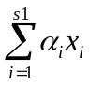
end
wp=w0;%%%%%特征空间中的超平面

%%%%%%%%%%%%%%%%%%%%%%%%%%%%%%%%%%%%%%%%%%%%%%%
%%%%%%%Testing%svm性能测试
%%%%%%%%%%%%%%%%%%%%%%%%%%%%%%%%%%%%%%%%%%%%%%

%[train, test] = crossvalind('holdOut',groups);
%cp = classperf(groups);
% Use a linear support vector machine classifier
%svmStruct1 = svmtrain(data(train,:),groups(train));
%classes = svmclassify(svmStruct,data(test,:));
% See how well the classifier performed
%classperf(cp,classes,test);
%cr=cp.CorrectRate
% % a leave-one-out prediction error estimate.
% load carbig
% x = Displacement; y = Acceleration;
% N = length(x);
sse = 0; %分类正确率
%i=1;
%w1=zeros(n,1);
%wp=zeros(n,1);
kk=10;%用leave-M-out 方法检测svm的性能，做10次取平均值
for i = 1:kk%第i次性能测试
i
[train,test] = crossvalind('LeaveMOut',m,10); % leave-M-out 内置函数
svmStruct = svmtrain(data(train,:),groups(train)); %选出数据并训练
[s1,s2]=size(svmStruct.SupportVectors);
%w0=zeros(n,1);
%for i=1:s1
%w0=w0+yy(i)*svmStruct.Alpha(i)*svmStruct.SupportVectors(i,:)';
%w0=w0+svmStruct.Alpha(i)*svmStruct.SupportVectors(i,:)';
%end
%w1=w0;
%wp=wp+w1;
classes = svmclassify(svmStruct,data(test,:)); %未进入训练的数据用于测试
cp = classperf(groups);%用于存储训练指标
classperf(cp,classes,test);
cr=cp.CorrectRate%分类正确率
sse = sse + cr; %分类正确率求和
clear cp；
end
corrr = sse./kk%取10次测试的平均值作为分类正确率
%%%%%%%%%%%%%%%%%%%%%%%%%%%%%%%%%%%%%%%%%%%%%%%%%%%%%%%%%%%%%%
%%%%%%imaging成像
load new_mask.mat
w=E*wp;%将特征空间中用svm训练的超平面wp投影回原始数据空间，得w用于成像
w=s.*w;%mask去Mask
w_max=max(abs(w));%取w绝对值的最大值
size_w=size(w,1);
for i=1:size_w
w(i,1)=w(i,1)./w_max;%normalize归一化
end
figure
plot(w)
title('the left_right SDM on single')
ww=reshape(w,53,63,46);
%%%%%% projection to nomalized brain投影到标准模板上
lw_mat2img(ww);
save PCA_SVM_leftright_hand ww
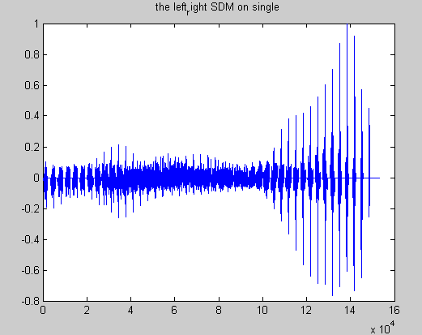
The learning weight vector (w) describing the separating hyperplanes(H). 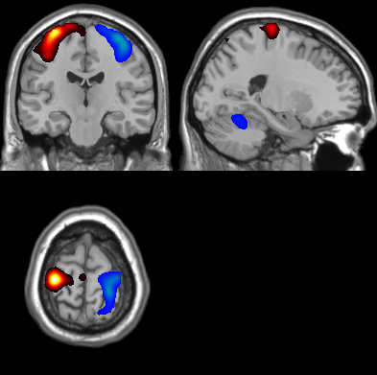
The discriminative maps between the left hand and right hand. Red color represent a positive value in a position of the discriminating volume (i.e. in a voxel) means that these voxels presented higher activity during right hand motion than during left hand in most of the training volumes, and a negative value (blue colored ) means lower activity during right hand motion than during left hand motion in most of the training volumes. The range of positive value:0.15-1.0; symmetry.

